|  |  |
| --- | --- |
|  | **Project Win** |
|  | **Business Requirement Document**  **(Project Win_BRDn02)** |

|  |  |  |  |  |
| --- | --- | --- | --- | --- |
| **Date** | **Prepared By** | **Reviewed By** | **Approved By** | |
| July 28, 2015 | Jerico Yumul  *Business Analyst* | Edward Co  Senior Project Manager | Michelle Tapia  Client | Eduardo Gutierrez  Client |

**Table of Contents**

0.0 Document Control 1

0.1 Purpose 1

0.2 Terms and Abbreviations 1

0.3 Related Documents 1

1.0 Project Definition 2

1.1 Background 2

I. Purpose and Objective 2

II. Benefits/Rationale 2

III. Dependencies 2

IV. Impact on Business 2

1.2 Scope (In/Out) 2

1.3 Scope Matrix 3

1.4 Flow Diagram 4

I. Proposed Business Flow Diagram 4

1.5 Stakeholders 6

2.0 SYSTEM Requirements 7

2.1 Security Requirements 7

I. Identification and authentication 7

II. Network Connections 7

III. Physical location 7

IV. System Management 7

2.2 Data Requirements 7

I. Data Classification 7

II. Data Volume 8

III. Retention and Archiving 8

2.3 User Requirements 8

I. Technology/Platform 8

II. Availability Requirements 8

III. Application Support 8

IV. Functional requirements 9

V. Reporting Requirements 11

VI. Required Codes 12

VII. User Access Types 12

VIII. User Help Requirements 12

# Document Control

## Purpose

The purpose of this Business Requirement Document is to specify in detail the requirements of **Project Win** in sufficient detail to enable the development of the project’s pilot run. This document aims to define the functionalities of the website for the purpose of communicating the specified requirements to all its intended audience.

This BRD is intended for the following audience:

1. **Michelle Tapia** & **Eduardo Gutierrez** who will provide input to help define and accept these requirements and to ensure that the requirements specified in this BRD completely meets the needs
2. ADEC project development team who will be responsible for designing and implementing the specified application as well as estimating the engineering effort required for its development and deployment.

## Terms and Abbreviations

|  |  |
| --- | --- |
| **Term/Abbreviation** | **Name/Description** |
| BAI | BPO Asia Institute |
| BSD | Business Solutions Development |
| SSL | Secure Sockets Layer |
| Level | * K-12 (Grade 9, 10, 11, 12) * College * Post Graduate |
| Node.js | Node.js® is a programming platform built on Chrome's JavaScript runtime for easily building fast, scalable network applications. |
| API | Application Program Interface. |
| Points | Acts as a currency in the system. |
| Operations Management | Group that will conduct back-end processing of the project. |

## Related Documents

|  |  |
| --- | --- |
| **Document** | **Description** |
| Project Win – Portal Simulation.pptx | PowerPoint presentation that acts as process simulator for the Portal site. The document also contains wireframes of the site. |

# Project Definition

## Background

### Purpose and Objective

The purpose of the project is to develop and market test a tutor marketplace portal.

### Benefits/Rationale

* To create a prototype product with core functionality needed to test business assumptions
* To gather data on initial market response, user behavior, and organizational capacity that will be useful for future business decisions

### Dependencies

*A-Plus Video Conference Platform* application program interface (**API**)

### Impact on Business

Input to creation of new business/new revenue stream.

## Scope (In/Out)

The Portal site will be used as a marketplace for students, parents, and tutors that are looking for online class. This would include profile creation, Tutor-browsing by category, and appointment request.

Operations Management will handle manual class scheduling, as needed, and customer support for Students and Parent either via email, phone, Skype or Viber. Customer support hotline number will be provided by Globe which will be available from 3pm to 10pm, Monday to Sunday.

Gathering of feedback from Students and Parents, Student experience report, and Tutor’s report on performance of the students will also be handled by Operations Management.

Ten (10) A-Plus Premium Tutors will also be part of the Tutors’ workforce and will be available from 3:00 pm to 9:50 pm Philippines Standard Time, Monday to Sunday.

Campaign site will no longer be part of the Development Team’s deliverables.

## Scope Matrix

|  |  |  |
| --- | --- | --- |
| **Scope** | Groups | |
| ADEC | GLOBE |
| Tutor screening | TRUE |  |
| Manual class scheduling | TRUE |  |
| Customer Support | TRUE |  |
| Report Generation | TRUE |  |
| Portal development | TRUE |  |
| QA Testing | TRUE |  |
| Deployment | TRUE |  |
| Vulnerability Assessment (VA) Scan | TRUE |  |
| Application support | TRUE |  |
| User Acceptance Test (UAT) | TRUE | TRUE |
| Information security management | TRUE |  |
| Security standards compliance | TRUE |  |
| Network structure & framework management | TRUE |  |
| Server access control implementation | TRUE |  |
| Web content (including legal disclaimers) |  | TRUE |
| Graphic design | TRUE |  |
| Customer Support hotline number management |  | TRUE |

## Flow Diagram

### Proposed Business Flow Diagram

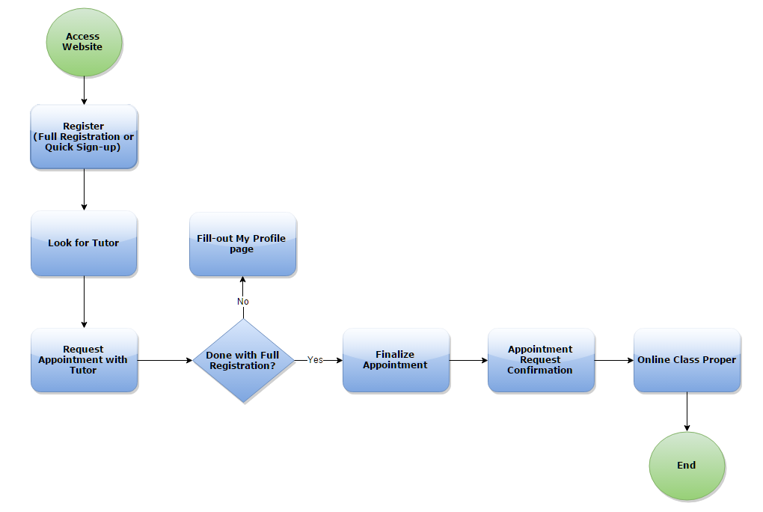

*Figure 1.4.1 – Parent/Student Flow*

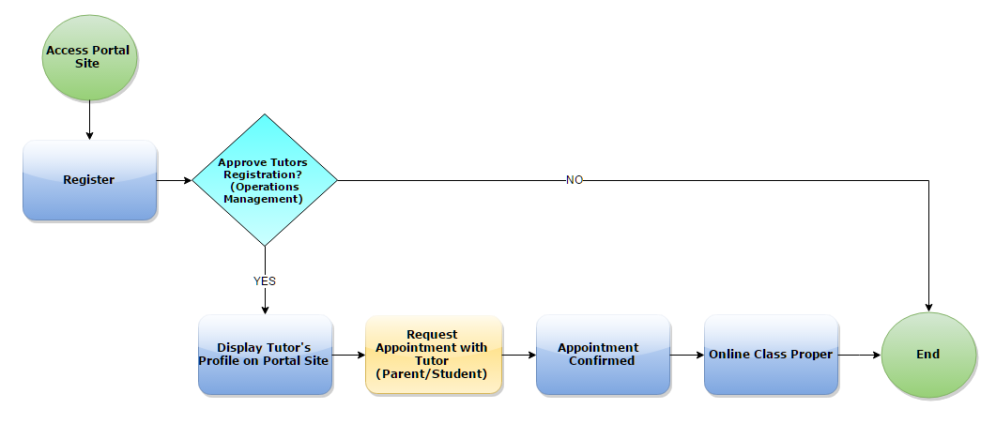

*Figure 1.4.2 – Tutor Flow*

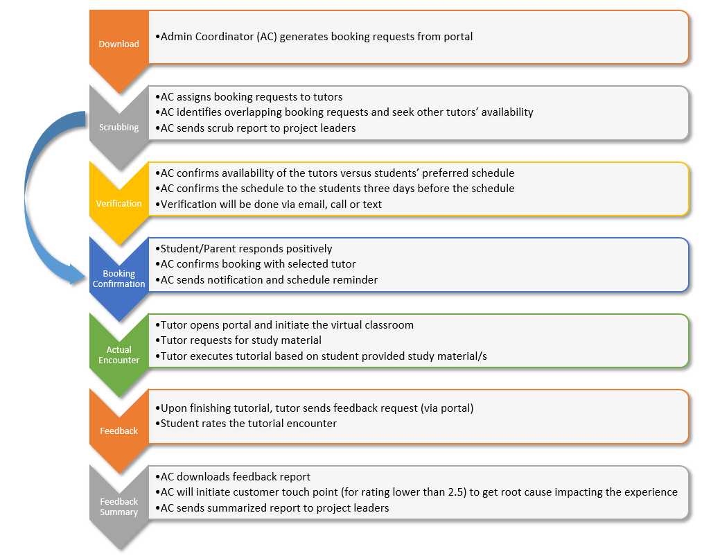

*Figure 1.4.3 – Operations Management Flow*

## Stakeholders

|  |  |  |
| --- | --- | --- |
| **Project Management** | | |
|  | **Name** | **Title** |
| 1 | Edward Co | Senior Project Manager |
| 2 | Jerico Yumul | IT Project Analyst |
| 3 | Mark Lester Picazo | EduTech Senior Developer |
| 4 | Soliven Ortega | Operations and Business Development |

|  |  |  |
| --- | --- | --- |
| **Project Owner** | | |
|  | **Name** | **Role** |
| 1 | Michelle Tapia | Client – Business/Project Owner & Proponent |
| 2 | Eduardo Gutierrez | Client – Project Manager |

|  |  |  |
| --- | --- | --- |
| **Project Members** | | |
|  | **Name** | **Role** |
| 1 | BTS - InfoSec | Test teams- provide inputs/feedback on the usefulness and performance of the system. |
| 2 | Corporate Standards | Compliance |

|  |  |  |
| --- | --- | --- |
| **Project Collaborators** | | |
|  | **Name** | **Role** |
| 1 | Carlo Adona / BSD  Development Manager | * Manages different development teams * Ensures the goals set down by top executives relative to an Information technology boundary, are achieved in the most cost efficient and effective manner, both short term and long term |
| 2 | Clark Turaray/ BSD  QA Lead | * Provides leadership and expertise throughout the entire QA lifecycle * Ensures the entire ITO organization’s compliance and adherence to processes and controls set as standards for its global operations |
| 3 | Ludeth Villarica / BTS  Infrastructure, Database and Network | * Manages and optimizes network structure and framework * Implements access controls * Maintains and monitors operations and performance of the network * Creates and tests backups, verifies data integrity |
| 4 | Luis Sicat / InfoSec  Information Security | * Safeguards project from any potential information security risks in compliance to security standards |

# SYSTEM Requirements

## Security Requirements

### Identification and authentication

* Username
* Valid email address format for both Tutors, Parents/Students, & Administrator
* Unique email address
* Password
* Alphanumeric
* Minimum of 1 special character
* Minimum of 8 characters in length
* Maximum of 20 characters in length

### Network Connections

* Accessible through public internet
* Security Sockets Layer (**SSL**) will be implemented

### Physical location

Server will be hosted in Amazon Web Services (**AWS**)

### System Management

Operations Managements will handled by BPO Asia Institute (**BAI**). This will include Tutor screening, manual class scheduling, and customer service. Back-end development and will be handled by Business Solutions Development (**BSD**). Website security, including website attack prevention and fix will be handled by Amdatex’ Information Security group (**InfoSec**) and **BSD**.

## Data Requirements

### Data Classification

The following items will be displayed on the Tutor’s public profile:

* Full Name
* Subject Matter Expertise
* Level (K-12, College, Post-Grad)
* Work Experience
* Education Background

The following items will be needed from the registering Tutor but will not be displayed on his/her public profile:

* Resume
* Diploma
* Government
* Contact Information

### Data Volume

5MB per file attachment

### Retention and Archiving

None for the Pilot run

## User Requirements

### Technology/Platform

Portal site will be developed using *Node.js*

### Availability Requirements

The final product must be available to the users:

* 24 hours a day, 7 days (Monthly Uptime Percentage of at least 99.95% as per **AWS’** Service Level Agreement)
* Any time the system must be brought down during these times, users will be notified with 24 hours of advanced notice
* If a problem occurs that brings down the system without warning, the users will be notified as soon as possible
* Whenever availability is interrupted, a notice will be sent when the system is again available

### Application Support

* Support hours will be Monday-Friday, 8hrs/5days
* For application & network support turn-around-time, refer to the table below:

|  |  |  |
| --- | --- | --- |
| **Severity** | **Case Resolution**  **Time Goal** | **Case Resolution Time Zero Revenue** |
| Critical | 4 hours within business hoop | 8 hours within business hoop |
| High | 24 hours within business hoop | 48 hours within business hoop |
| Medium | 48 hours within business hoop | 96 hours within business hoop |
| Low | 72 hours within business hoop | 288 hours within business hoop |

### Functional requirements

1. **Parent**

* On registration, there should a section to input his/her information and his/her child’s information
* Parent should have an option to register via quick sign-up; Quick sign-up will only require username & password to create an account
* Parent should receive an automated email confirmation upon successful registration and when requesting an appointment
* Parent will have a page that contains list of his/her child’s appointments
* Parent can cancel an appointment at most of 1 hour before the appointment

1. **Student**

* On registration, there should be a validation of Student’s age; If age is below eighteen (18), there should be another section displayed for inputting parent/guardian’s information
* Student should have an option to register via quick sign-up; Quick sign-up will only require username & password to create an account
* Student should receive an automated email confirmation upon successful registration and when requesting an appointment
* Student will have a page that contains list of his/her appointments
* Student can cancel an appointment at most of 1 hour before the appointment
* If Class Status is Completed, Student can rate the Tutor from 1-5 Star and leave a remark

1. **Tutor**

* On registration, tutor can attach documents
* Tutor can add multiple contact information, social media/instant messaging accounts, educational background, and work experience
* Tutor should receive an automated email confirmation upon Operations Management’s approval of registration.
* Upon login, Tutors will have a dashboard page where they can view their appointments
* On Appointment record page, Tutor can select the following Session Status:
* Cancelled
* Cancels the appointment
* Can only be done at most of one (1) hour before the actual appointment
* No Show
* The Student wasn’t able to attend the session
* Points will be credited to the Tutor
* Will be shown only during and after the appointment schedule
* Completed
* Tutoring session was conducted
* Points will be credited to the Tutor
* Will be shown only during and after the set appointment
* After selecting a Session Status, there will be a Remarks section that contains upload document function (optional, word document, text document and image files only) and a text box for inputting remarks (required)

1. **Admin Coordinator**

* Can view list of all registered Students/Parents and Tutors and access their profile
* Manual Class Scheduling
* For appointments that is for rescheduling, once Parent/Student agrees to select a new schedule or a new Tutor, Admin Coordinator will add the appointment on the Tutor and Student’s appointments list
* For disputed appointments, Admin Coordinator can manually schedule a class and tag it as a make-up class; Parent/Student won’t be charged from a make-up class and Tutors, either the disputed one or a new one, will not earn Points from the make-up class
* Admin Coordinator can access Report modules
* Admin Coordinator users can add new Admin Coordinator users
* Admin Coordinator can also deactivate/re-activate Tutor accounts; Re-activated Tutor account will be subject again for profile approval

1. **Other Functional Requirements**

* The website should be responsive/adaptive
* Only one account per email is allowed
* During registration process, there should be a selection whether the registering user is looking for a Tutor or registering as a Tutor
* There should also be a selection whether the user looking for a Tutor is a Parent or a Student
* The web application should be able to launch the A-Plus Video

Conference Platform if opted by the users, Tutor and Student for their tutorial session but this is limited up to first 20 concurrent users only which will prompt or disable the usability of the A-Plus Video Conference Platform until a slot becomes available; this is only for the Pilot run

* During Pilot stage, every Parent/Student that registers will automatically receive free Points worth Two Thousand Five Hundred (2,500)
* Free Points can only be consumed within the Pilot run
* Any appointments that will be set beyond the Pilot run will not be accepted
* Points crediting & deduction:
* Once a Parent/Student requests an appointment to a Tutor, Points will be deducted from their account
* Once an online class has been completed, Points will be credited to the Tutor
* If a Parent/Student cancels an appointment, appointment will be subject for rescheduling and there will be no further deduction of Points to them.
* If a Tutor cancels an appointment, appointment will be subject for rescheduling and there will be no additional Points credited to the selected Tutor and there will be no further deduction of Points from the Parent/Student.
* If the appointment was not cancelled and the Student did not show up, Points will not be returned to the Parent/Student ‘s account and it will be credited to the Tutor
* Users has an option to activate/deactivate their account
* If a Tutor deactivates his/her account, his/her profile cannot be viewed by Parents/Students

### Reporting Requirements

* Appointment Matrix Report
* Payment Method Statistics Report
* Platform used Statistics Report
* Users Report:
* Parents list
* Students list
* Tutors list
* Age Statistics
* Country Statistics
* Level Statistics

### Required Codes

None

### User Access Types

1. **Parent/Student** - User type that can browse for Tutors and set appointments with them
2. **Tutor –** User type that will be conducting the online class
3. **Admin Coordinator -** User type that can do the following on the Website:

* View and approve Tutors’ registration
* Manual Scheduling
* Make-up class creation
* Session rescheduling
* Deactivate/re-activate Tutor account
* Access Report modules

### User Help Requirements

User Reference Manual